LIMITED SPACES AVAILABLE! FIRST COME FIRST SERVED!
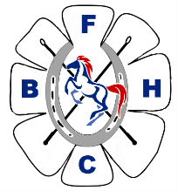. Presentation Evening – SATURDAY 17TH OCTOBER
BLACKPOOL & FYLDE HORSE CLUB
TO BE HELD AT STANLEY PARK GOLF CLUB HOUSE
NORTH PARK DRIVE, BLACKPOOL. FY3 8LS.
RECEPTION 6.30PM
BUFFET STYLE MEAL
ADULTS -£16
MEAT & POTATO PIE
CHEESE & ONION PIE [VEGAN]
SERVED WITH GARLIC BREAD AND SEASONED CHIPS
SELECTION OF DESSERTS
CHILDREN 12 & UNDER - £7
CHICKEN NUGGETS & CHIPS
ICE CREAM
PARTY NAME- | HOW MANY? | ANY VEGAN?
ADULTS @ £16
CHILDREN @ £7
TOTAL PRICE | £

PAYMENT DETAILS
PayPal – bfhc1948@gmail.com
Bank Transfer – Barclays bank, sort code 20-10-03 acc 30337803.
Cheque – payable to Blackpool & Fylde horse club.
Please email form to bfhc1948@gmail.com
OR post to BFHC,367 Blackpool Old Road, Blackpool Fy3 7LX.

